**Final Project Report – Team 3 (C)**

**Course: IS 684-101 Business Process Innovation**

**Nelson Mercado**

**Tony Wang Wong**

**Vamsi Krishna Channa**

**Date: December 8, 2015**

**Table of Contents**

1. Executive Summary..................................................................................................3
2. Introduction and Background...................................................................................4
3. Opportunity or Problem Definition..........................................................................5
4. Alternatives Considered and our Recommended Solution.......................................6
5. Benefits Estimates and Assumptions........................................................................7
6. Cost Estimates and Assumptions..............................................................................8
7. Risk Factors and Mitigation......................................................................................8
8. Implementation Timeline...........................................................................................9
9. Appendices...............................................................................................................10

**Executive Summary**

It is to our understanding that the publishing industry is similar to the music industry before it. The publishing industry is undergoing a rapid transformation, with emerging revenue streams such as electronic books, audio books and print-on-demand gaining significant ground. While sales of printed books remain relatively stable, the demand for digital content is set for stellar growth. For example, the forecasted spending on digital content in Europe is expected to increase from $ 12 million in 2007 to $ 1.4 billion this year. An expanding market means a new source of income to supplement their traditional print publishing segment. As students of Professor Egan’s business process innovation class. We understand that it is imperative to acquire the means to effectively manage sales, royalties, management, promotion and distribution to complement its traditional business of the print edition to in order to succeed in the digital era.

The opportunities that are presented arise from the challenges our publishing company faced on a daily basis. These challenges include the generic types of process problems that Harmon have identified and they are categorized as input and output problems. To be more specific, our company faces the challenges during the digitization of intellectual property and the distribution of content. Some of the end users such as customers are complaining about the mistakes in the papers and magazines. In addition, the font size and color are not visible and some of the users are complaining about the font style provided. These challenges are a result of the fact that some of our staffs do not have the proper technical knowledge to utilize the tools available to format and to support the task of documentation and publishing. In addition, the administrative staffs are not updated with up-to-date management issues, resolutions, and status.

As a team of business process innovators, we recommend our company to introduce and utilize SAP which can be customized as a solution dedicated to accommodate printing and desktop publishing. It will be fully compatible with the rapid adoption of e-business model by maximizing the value of their intellectual property rights, reducing the costs while increasing the operational efficiency and transparency. In terms of business impact, we aim to improve incomes content with new market channels and to drive smarter decision through its lines of business analysis and reporting powerful decisions to management.

**Introduction and Background:**

The Digital Newsstand transforms publisher files into an epub to be sold online. The process at hand is at follows, initially the publishers upload files which a Production Coordinator reviews and processes and passes these files to an operator which extraction meta information, once the Operators finishes, the Production Coordinator combines the meta data and processed files into an EPUB. Management than ingest these files into the Digital Newsstand server, to be put on sale in the digital store.

The organizational context involves its “Operating Environment” and it involves the both internal and external features of the organization. For example, Times Magazine which is one of the largest publisher of magazines and newspapers throughout the world. The company has changed their mode from paper to digital format which is very helpful for the users and this also met the technology needs. The company is also trying to develop the digital newsstand for portable devices. The company is trying to provide in digital color format to win over its competitors. This is the best example for strategic planning.

There are seven important macro-environmental factors which deal with every process. The Steeple Factors for our system are social, technology, and environmental.

* Social: The population who are using the internet are increasing day by day and the chance of E-books will increase.
* Technology: The technology is innovating and this will help all the users to read their book on mobile or E-book reader.
* Environmental: Implementing this E-books will save lot of paper and also environmental friendly. This will be a best example for the other organizations.

**Opportunity or Problem Definition**

The arrival of Internet technology and mobile has revolutionized a very traditional industry, giving new shapes and a new life. Not long ago, few experts could have predicted exactly how the digital age would have impacted the publishing industry. Giving the opportunity to improve the business process of our digital company, we have identified a few problematic processes that can be improved. There are problems with digital technology management; publishing techs is either antiquated or is light-years ahead of its time in terms of skills needed for their jobs. In publishing, many companies have in their ways, stubborn, with chunky, limiting legacy technology and practices that allowed the competition to skip ahead. The early innovators also have their fair share of problems since, historically, you have to choose quickly evolved for its current time advances in publishing and were expensive to implement, and unfair ran with these costs to the public.

Ideally, companies with simple tools publishers might assume that continues to keep pace with the evolving media landscape step so that publishers would still only care about crafting quality content to build. Instead, publishers have taken it upon themselves to optimize for mobile browsing, implement unique advertising channels and combating social media.

Also what most publishers think they know about the Web is wrong. The coveted page view is no longer the only success metric for publishers - it comes to commitment. Of course, the greatest efficiency will come when platforms help find publishers and understand all of this is in a way that is uniform within the industry.

To revolutionize our company, we are strongly involved with the major stakeholders. They are the publishers, production coordinators, operators, digital newsstand management, and customers. We aim to be more agile and bold when it comes to creating innovative digital publishing business models.

**Alternatives considered and our Recommended Solution:**

The alternatives we have considered are SharePoint, ERP, and SAP. Microsoft SharePoint can help us in achieving our goals and aspirations by sharing, organizing, discovering, building, and managing knowledge on a global level and across all elements of the company structure. Microsoft SharePoint can help the company by connecting with employees across the enterprise. It can be used to keep documents in sync, to engage with people, to share ideas and to reinvent the way employees work together regardless of their locations. SharePoint sites can be created for the employees to organize content, share ideas and manage projects through a single location that keeps track of versions, individual contributions, feedback and comments.

On the other hand, SAP and ERP are currently the two leading vendors. Oracle is also a leader manufacturer of large enterprise databases. SAP is the world's largest enterprise management software and business solutions provider. We cannot guarantee that ERP process is optimal, but I believe that the SAP process is definitely the best. Since Fortune 500 companies, including 80% of IT companies can use SAP. Thus, our recommendation is to use SAP which can be customized as a solution dedicated to accommodate printing and desktop publishing. It will be fully compatible with the rapid adoption of e-business model by maximizing the value of their intellectual property rights, reducing the costs while increasing the operational efficiency and transparency. In terms of business impact, we aim to improve incomes content with new market channels and to drive smarter decision through its lines of business analysis and reporting powerful decisions to management.

**Benefits estimates and assumptions**

The estimated benefits of our SAP initiative are substantial. We plan to eliminate back and forth emails, ensure production Schedule will always be automatically updated while eliminating the process of production coordinators update. We will give management a clearer view of what status of production and create a paper trail for a product, title, and issue. In addition, we expect to eliminate emails between operator and production coordinator, automatically create production tickets and will provide a wiki for process and troubleshooting documents while automatically deliver files to the ingestion sever by passing that management has to manually deliver.

**Cost estimates and assumptions**

Digital News Stand business is the most profitable business in the current market trend. According to our research the business is expected a revenue of 24.6$ billion and the times magazine has the maximum share in the market and it is boosting every year. The cost on the number of employee in the organization is up to 1$ million dollars. Addition of SAP in the business process will cost up to 10$ million and this will eliminate lot of steps in the process. If there is no income growth in the organization the initial investment can be achieved in approximately 5 years. As Time digital news stand is the leader in the market, implementing this SAP will speed up their process in releasing the latest magazines in the market. Implementing this module will eliminate many middle men in the process. The implementation will take approximately 8 months. The new process will definitely attract new customers and will increase the revenue of the company.

**Risk factors and mitigation**

The majority of the risks are associated related to software risks and personnel.

**Software risks:**

* After developing the application the competitors may come with other better application for their process.
* The costs are very high and the loss will be very high if the project will be a failure.
* There can security attacks on the organization by which the company may loss lot of data.
* Bugs in the new software system may delay the process.

**Personnel risks:**

* It may find hard for all the employees to learn about new technology and business process.

**Environmental risks:**

* There can be natural disasters like earth quakes, hurricanes etc. that may affect the system.

**Implementation Timeline**

|  |  |  |
| --- | --- | --- |
| **S.no** | **Task Name** | **Month of Completion** |
| 1 | **Analyzing the software’s** | **1 month** |
| 2 | **Purchasing SAP software** | **1 month** |
| 3 | **Installing the software** | **3 months** |
| **4** | **Software testing** | **1 month** |
| **5** | **Implementing the software** | **15 days** |
| **6** | **Employee training** | **1 month** |
| **7** | **Start using for business process** | **10 days** |

**Appendices**

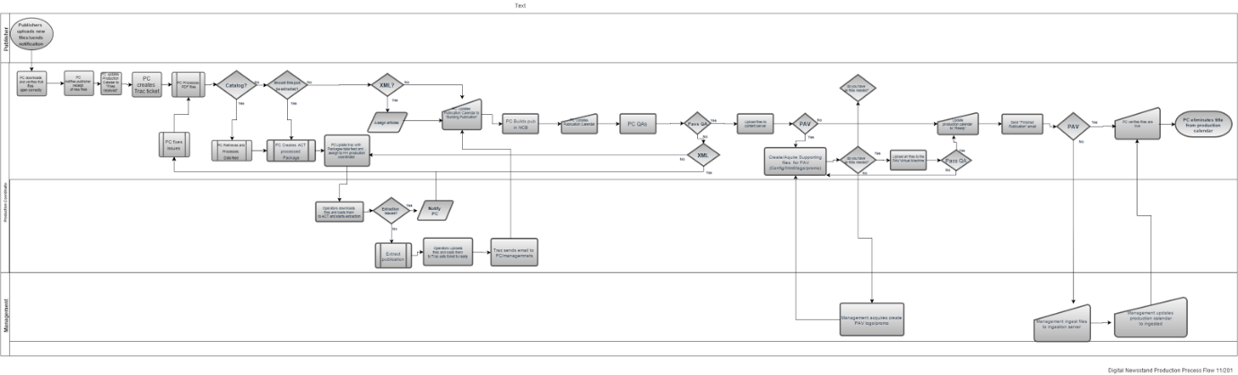**High-level diagram of the current process**

**High-level diagram of the “To-Be” process** 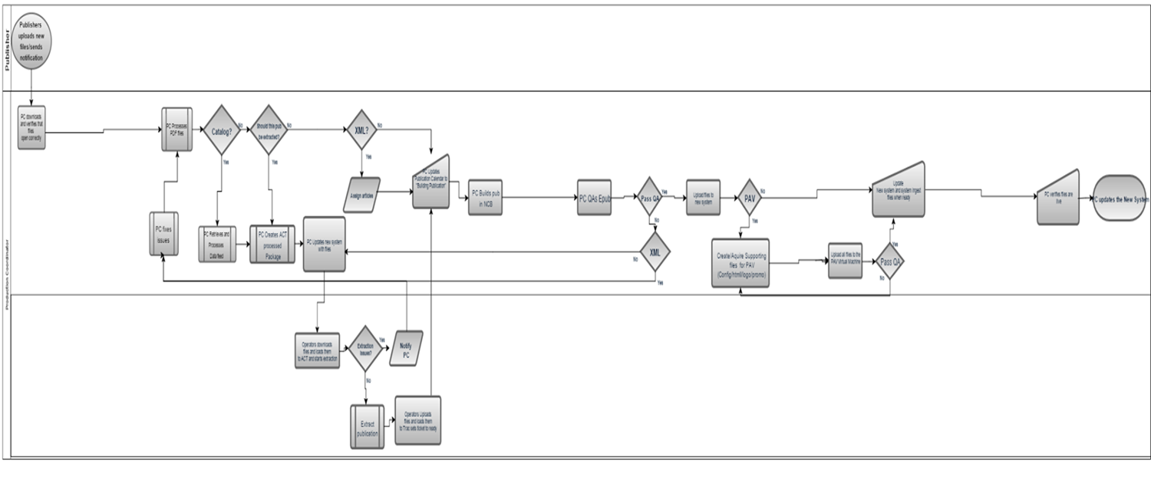

**Project Scoping Diagram for the Process**

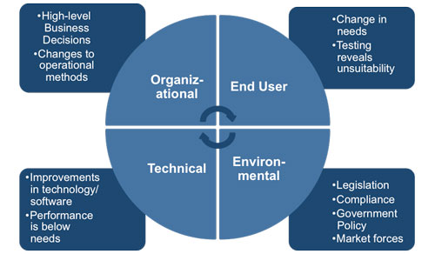

**Work System Snapshot of the existing Work System your process is part of.**

|  |  |
| --- | --- |
| Customers | Product & Services |
| Computer users  Smartphone users  Tablets users  Internet users | Ebooks  Digital magazines  Digital Catalog  Web readers |

|  |
| --- |
| Work Practices |
| PC receives files from publishers  PC process, crops/color correct files  PC troubleshoots files  PC creates tickets to be assigned to operators  PC updates production calendar  PC Builds Epub  Operator Extracts meta data  Management ingests Epubs |

|  |  |  |
| --- | --- | --- |
| Participants | Information | Technologies |
| Publisher  Production Coordinator  Operator  Management | on sale date  delivery date  Meta extraction information  Production schedules | Computer  Internet  Email system  Various applications  Tablet Devices (for QA) |